Documents : C:\Users\User\Documents\POWER BI SATISH ,GMAIL
- Power query is the ETL tool for Power BI ,which extract ,transform & load the data.
Session 2
Lesson 2 - Import Data into Power BI
Learn how to efficiently import data from various sources into Power BI. Explore data connectors and set up your data structure for further analysis and reporting
 Import data from Excel, CSV, and databases
Overview of data connectors in Power BI.
Howtohandle and format data during import
Setting up the data structure for analysis.
To add this filter in excel Press ALT+A+T (Shortcut)
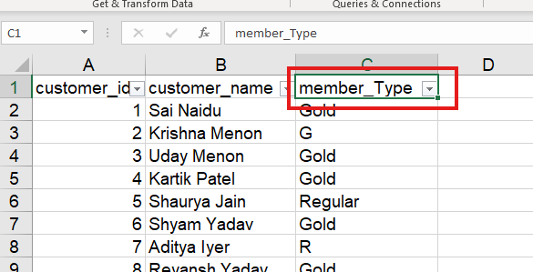

- Import query mode & direct query mode: With DirectQuery, the data is not stored in Power BI, so it can handle large data sets, but it may not be as flexible in terms of creating complex data models. Performance: The Import method can offer better performance than Direct Query, as the data is stored locally and can be optimized for performance.
- Lesson 3 - Data Transformation of 30-Days Power BI Micro Course by Satish Dhawale.
- You will learn in this lesson (In Hindi):-
- Master how to transform raw data into clean, structured information using Power Query. Learn essential data-cleaning techniques to prepare your datasets for analysis.
Use PowerQuery to clean and shape data.
Remove duplicates, filter rows, and transform columns.
Apply data types and column renaming.
Understand common data transformation techniques.
Lesson 5 - Modeling- Create Relationships
Explore how to establish relationships between tables in Power BI to create a cohesive data model. Learn about cardinality and cross-filtering for better data interaction.
Introduction to data modeling in Power BI.
Create and manage relationships between tables
Understand cardinality and cross-filtering.
Howtovisualize relationships in the model view

- Difference between DIMENSION TABLE & FACT TABLE
Data Type:
Dimension tables contain qualitative data (text descriptions) while fact tables hold quantitative data (numbers like sales amounts, quantities).
Purpose:
Dimension tables provide context and allow for filtering and grouping data, whereas fact tables are used to calculate and analyze metrics.
Relationship:
A fact table typically has foreign keys linking it to multiple dimension tables, allowing you to analyze the "facts" across various dimensions.
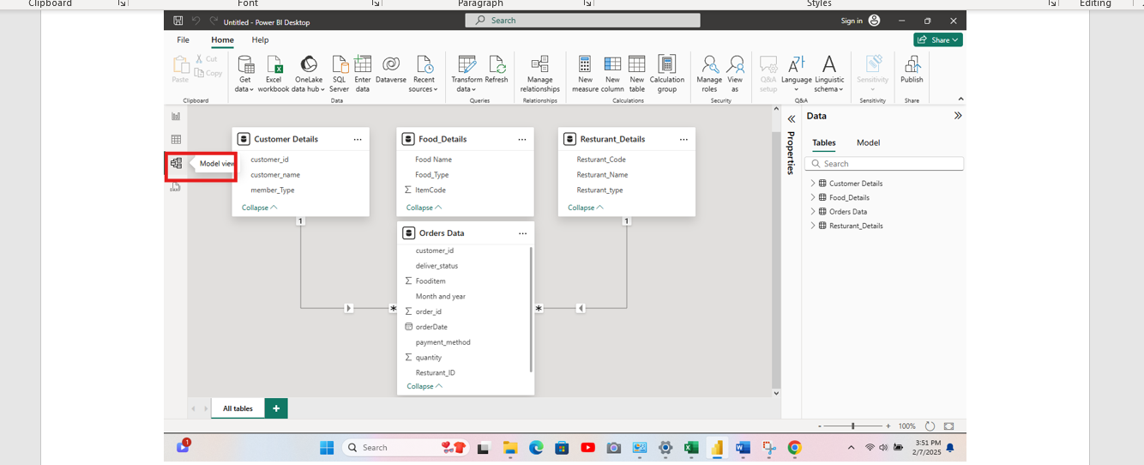
When we click on model view, it will automatically create the relationship bw table which consist of same column name & will give the cardinality also.
Here Customer details, food_details & restaurant_details are called as dimension table whereas order data is called as fact table or data table.
- If relationship is not detected automatically then go to
FileOptions & setting OptionData load(in current file)
Check this option & click on ok. 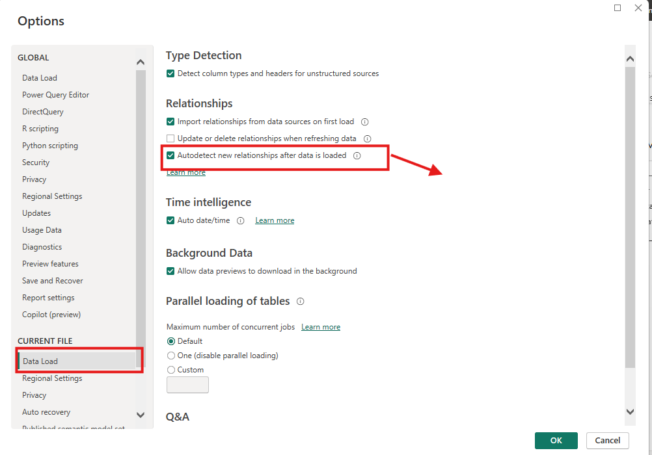

- To delete the relationship, simply right click on line & then click on delete
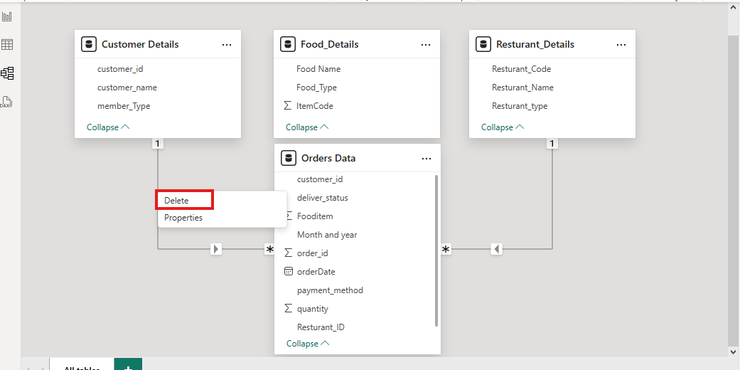
- In case relationship is not detected automatically, we can do it manually by simply drag & drop. Drag Item_code from food_details & drop it on food_item in orders_data table.
-----------------------------------------------------------------------------------------------
- Lesson 6 - Page Formatting
- Discover techniques for formatting Power BI report pages to enhance presentation and readability. Customize themes, layouts, and design for a professional look.
Format page layouts and customize themes.
Adjust page size and orientation for reporting
Apply consistent page formatting for professional visuals.
Set default visuals and templates for your reports.

Before adding any visualization, By clicking on format your report page we will get many option, We can rename the name of page, we can change the colour, add images in wallpaper etc. & by reducing transparency we will be able to see canvas colour changes


